Project 14-1 To-Do List
Create an app that uses data from the JSON Placeholder API to display a list of to-do items for a specified user. After selecting a user, the app should look like this:
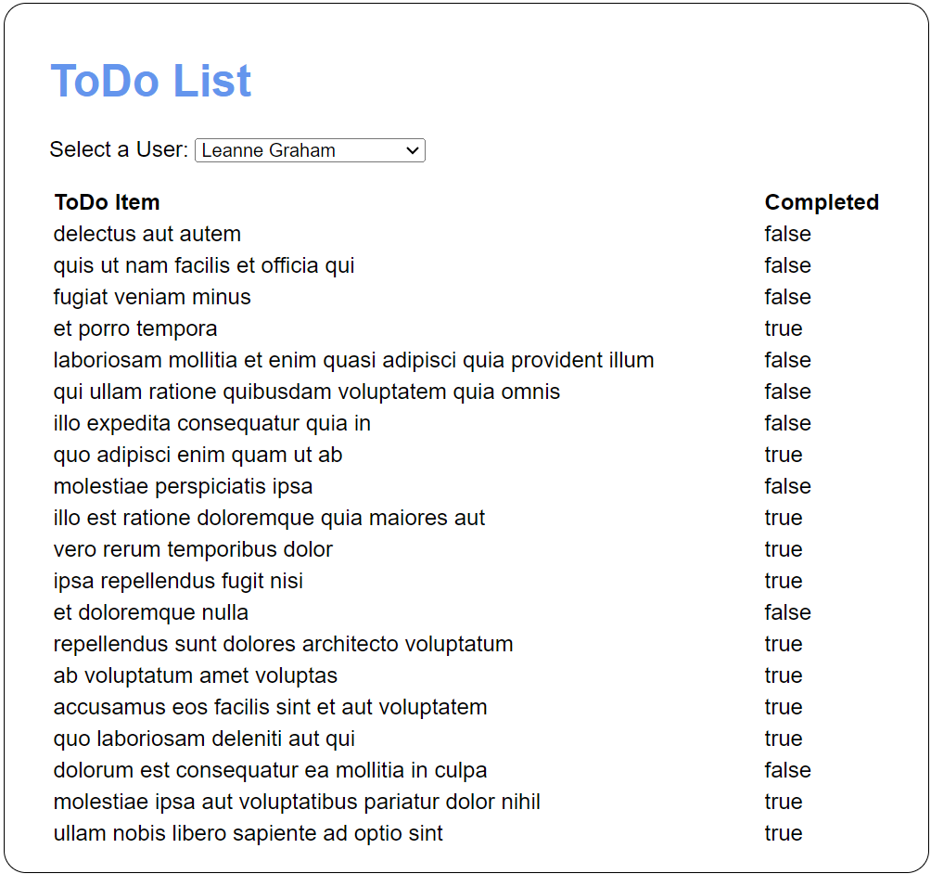
Specifications
- Use the files in this folder to help you develop the app:
projects\ch14\todo_list\
- You can use the following links to access a list of users and the to-do items for a user (you’ll need to supply a user id number between 1 and 10):
https://jsonplaceholder.typicode.com/users
https://jsonplaceholder.typicode.com/todos/?userId=#
- When the app first loads, it should display the to-do items for the first user in the <select> element.
- When a new user is selected, the app should display the to-do items for that user (and only that user).

Project 14-2 Mars Rover Photos
Modify an app that uses NASA’s Mars Rover Photos API to allow you to view photos from any of the rovers sent to Mars by NASA. After selecting a rover, a date, a camera, and \clicking the “View” button, the app should look like this:
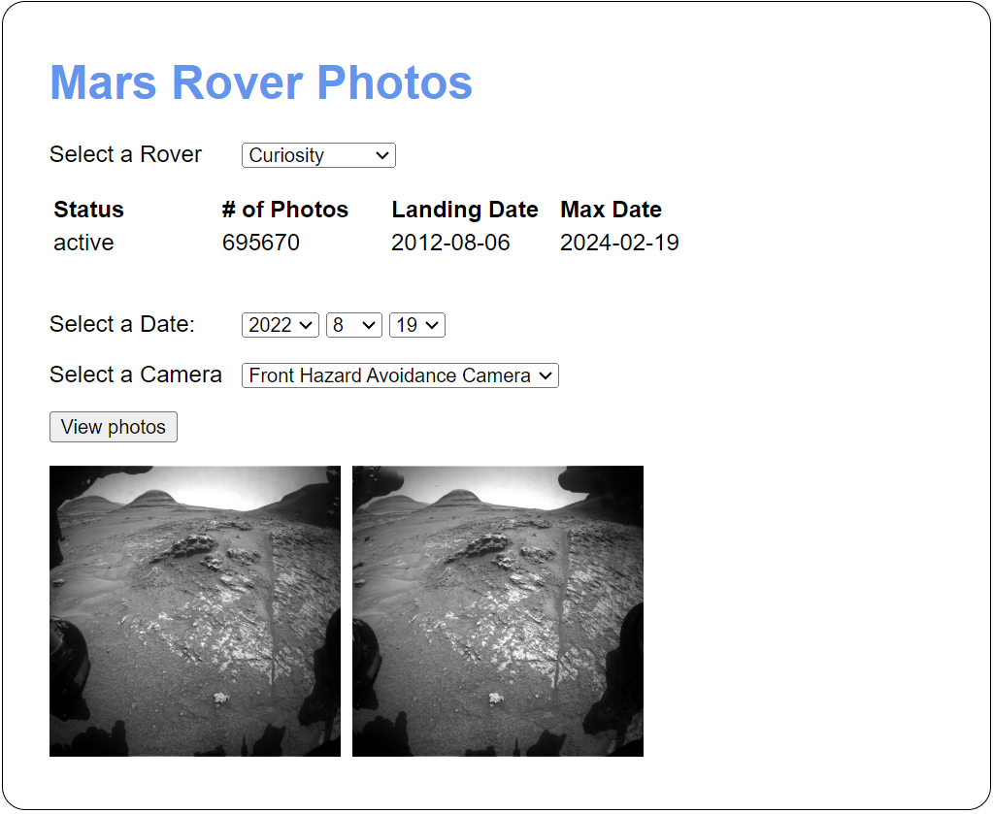
Specifications
- Use the files in this folder to help you develop the app:
projects\ch14\mars_rover\
- To get a list of all the Mars rovers, use this URL:
https://rovers.nebulum.one/api/v1/rovers
- To get the photos for a specific rover and date, update the URL like this: (won’t actually be needed)
https://rovers.nebulum.one/api/v1/rovers/Curiosity/photos/?earth_date=2024-2-19
- To get the photos for a specific camera, update the URL like this: (You will want to test using this data… ex// rover is Curiosity, date is 2024-2-19 and the camera is MAST_LEFT
https://rovers.nebulum.one/api/v1/rovers/Curiosity/photos/?earth_date=2024-2-19&camera=MAST_LEFT
- When the app loads, it should populate the “Select a Rover” drop-down.
- When the user selects a rover, the app should use data for the selected rover to display the status, # of photos, landing date, and max date and to populate the Select a Date and Select a Camera drop-downs.
- When the user clicks the View photos button, photos should display as shown above.

